Proje 5

Cemalettin Yavuz Üye

17070001011

Introduction:

In this project, our aim is to create an election application, the user will be able to use the game to a party he wants, and at the same time, he will be able to indicate which candidate he chose in that party, and if the user does not want to choose a party, he will be able to vote for the candidates without choosing a party.

The user will also be able to observe which party gets how many votes and what candidate got what percentage.

Cost: The apps I use are netbeans and I didn't spend any cost for the project

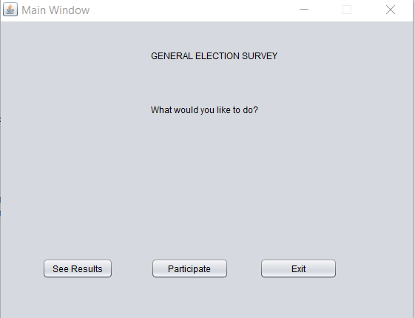

When we run it for the first time, we see Main Window, and if we want, we can click See Results and see the percentage of the votes of the parties, if we want, we click Participate and proceed to the voting phase.

If we click See Results, Massage buttons appear.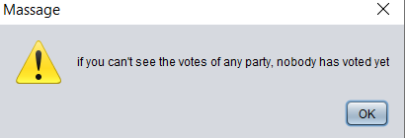

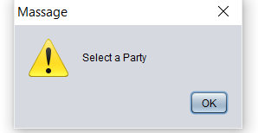

Along with our message button, the General Statistitics Window shows us how many votes each party has received here.

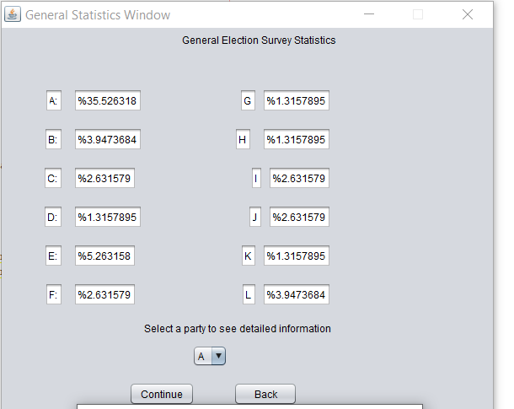

In General Statistic Window button, you can select the party and click continue button to observe how many votes the candidates of the party you want received.

After pressing the Continue button, we see General Statistic Window and we can see how many votes the candidates of the chosen party got.

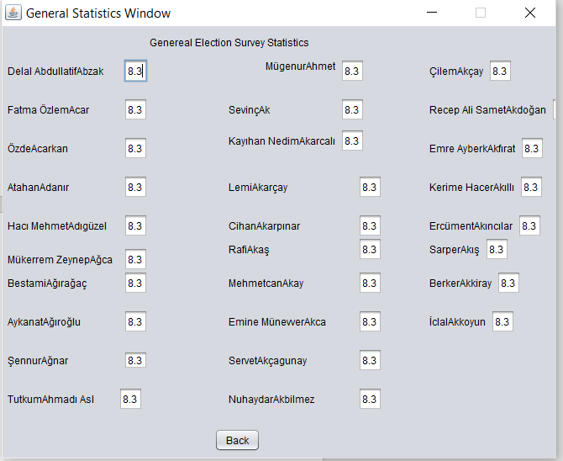

If we click Participate in the Main Window, a message will appear first.

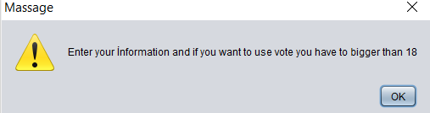

After the message, you will be asked to enter your information and if you press back you will return to the Main Window.

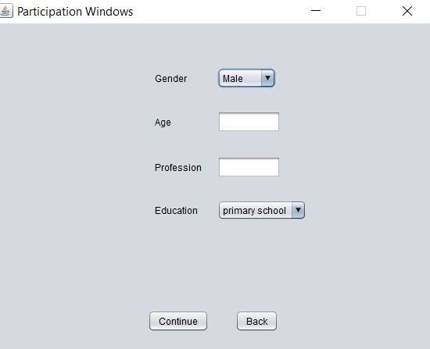

If you press Continue, you will be presented with a message button.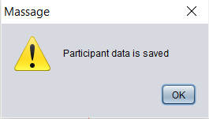

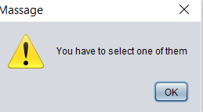

After the message button, a Window named Party Selection opens and you can choose which Party you can vote in, and if you do not support the party and only want to vote for the candidates, you can press None and vote for the independent voters.

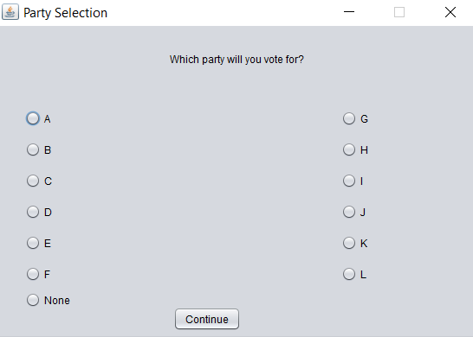

If you select one of our parties and click Continue, you will see the candidate list of the selected parties. When you choose our party, you will vote for 28 candidates, but our code will ask you to choose 14 to keep it in our data.

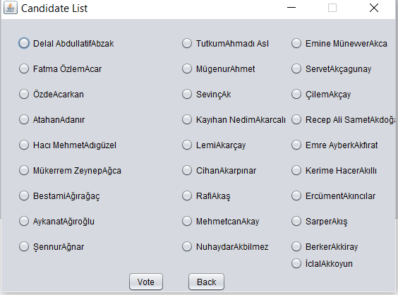

If you select None in the Party Selection section, you will see a list of 336 candidates from 12 parties, and if you choose to vote for 28 of the candidates, you will vote if you select our candidates and click Vote. If you click back, you will be directed to Party Selection.

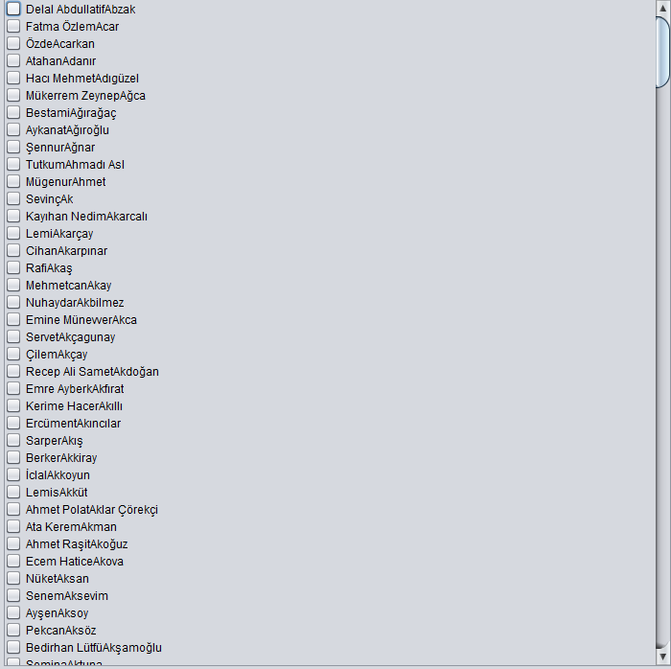

Sequence Diagram:

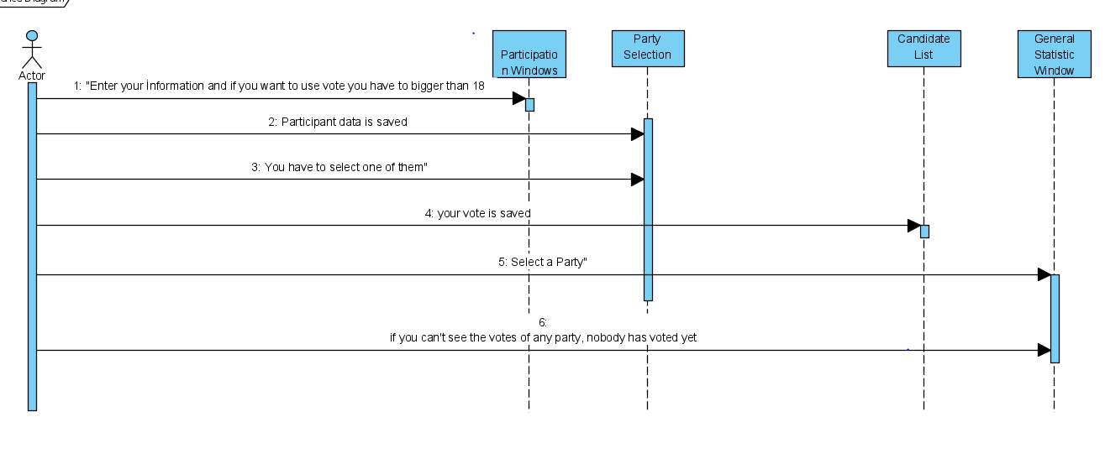

Activity Diagram:

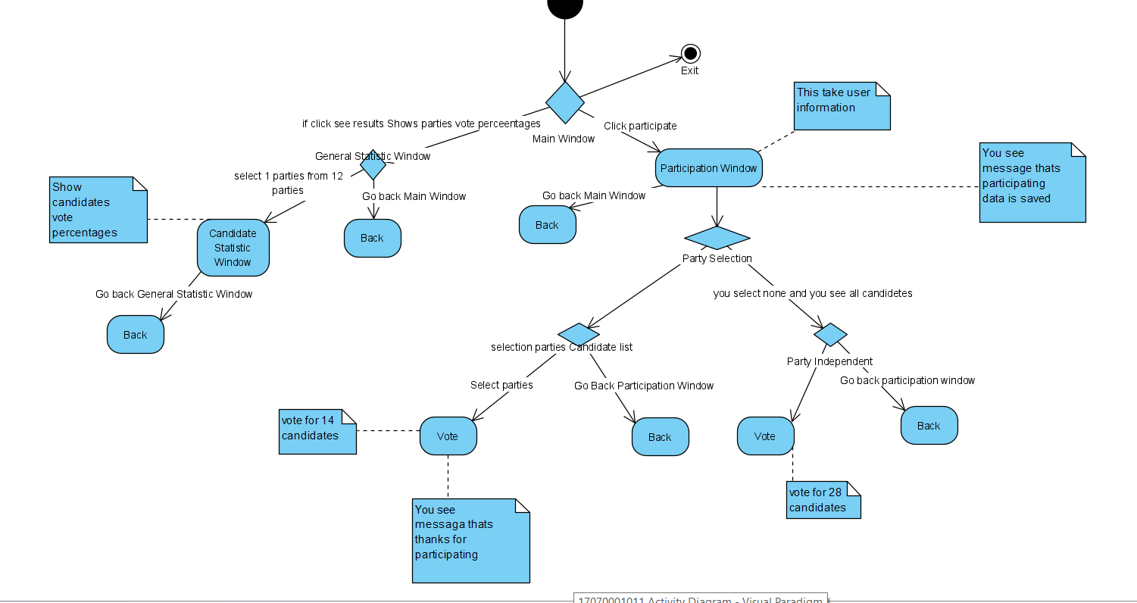

Use-Case Diagram:

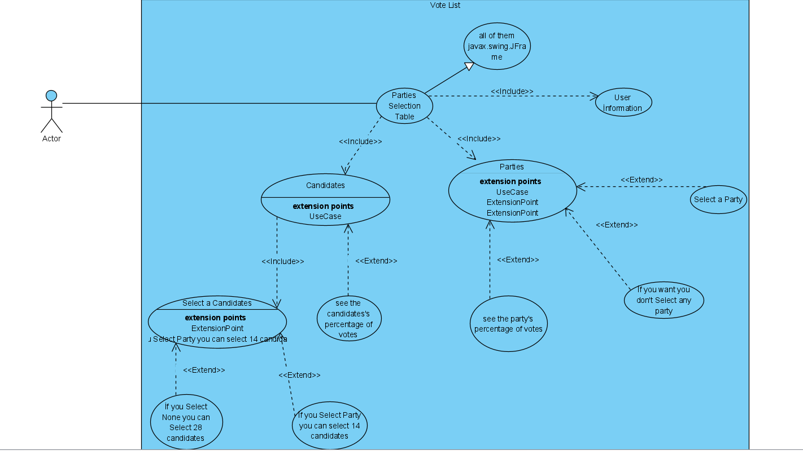

Class Diagram:

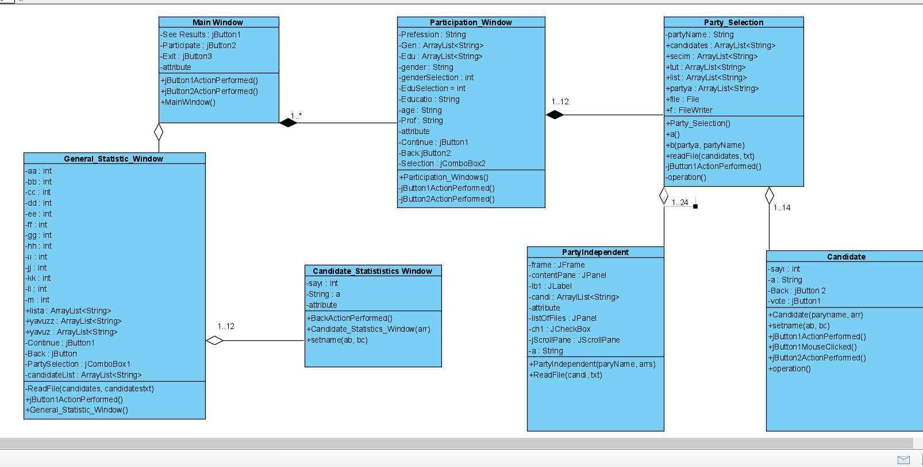

What the Project Brings Me:

It has been a good experience for me since I have never done a big project before. Also, since it is a breeding effort against time, this has been a good project for me to see the difficulties we will face in our business life. In the project, I put the file reading and writing files in a place that I will never forget, because we have to record every information. For this, I wrote to the file and to read that information, I read from the file and never lost any information. I learned that I did not know the Arraylists too for myself, and I understood this project well, and of course, it was a very efficient task in terms of using interface. I think we can only create a Button label from the Design section in the interface, but since I used 330 checkboxes in this project, I researched and learned that we created very easily with for in the Source section, I have never created a jar file before. Thanks to this project, I learned to create a jar file. In this project, I encountered more try catches than I have ever used, and I also learned to solve them and search online. It was very difficult when it was a big project, but when I tried to solve it piece by piece, I saw it became a whole. Now, my code writing style is not to enlarge my eyes as a whole, but I saw that everything is easier when I take it apart. In fact, this code showed me that I can find and learn everything I don't know by teaching me the most research on the internet.